RESTful Webservices using JAX-RS

Topics

1. RESTful webservice
2. Designing Restful Services
3. Developing & Deploying REST API
4. Content Handling
5. HTTP response & Exception Handling
6. Securing REST Apis
7. Swagger

Pre-requisites

1. Core Java - OOPs, Exception Handling, Collection

Software requirements

1. JDK 17 or later
2. Eclipse or STS
3. Apache Tomcat Server
4. Permissions to download Maven dependencies

Java is an object oriented programming language

OOPS

* Encapsulation
* Inheritance
* Polymorphism
* Abstraction

Encapsulation: Hiding the data (variables) and accessing them only through public methods

User:

* store
* login
* update
* delete

Create a Java Project

Eclipse -> File -> New -> Other -> Type Java project

Package: 2 level package structure

com.oracle.dao  
com.oracle.service  
com.oracle.controller

Profile.java

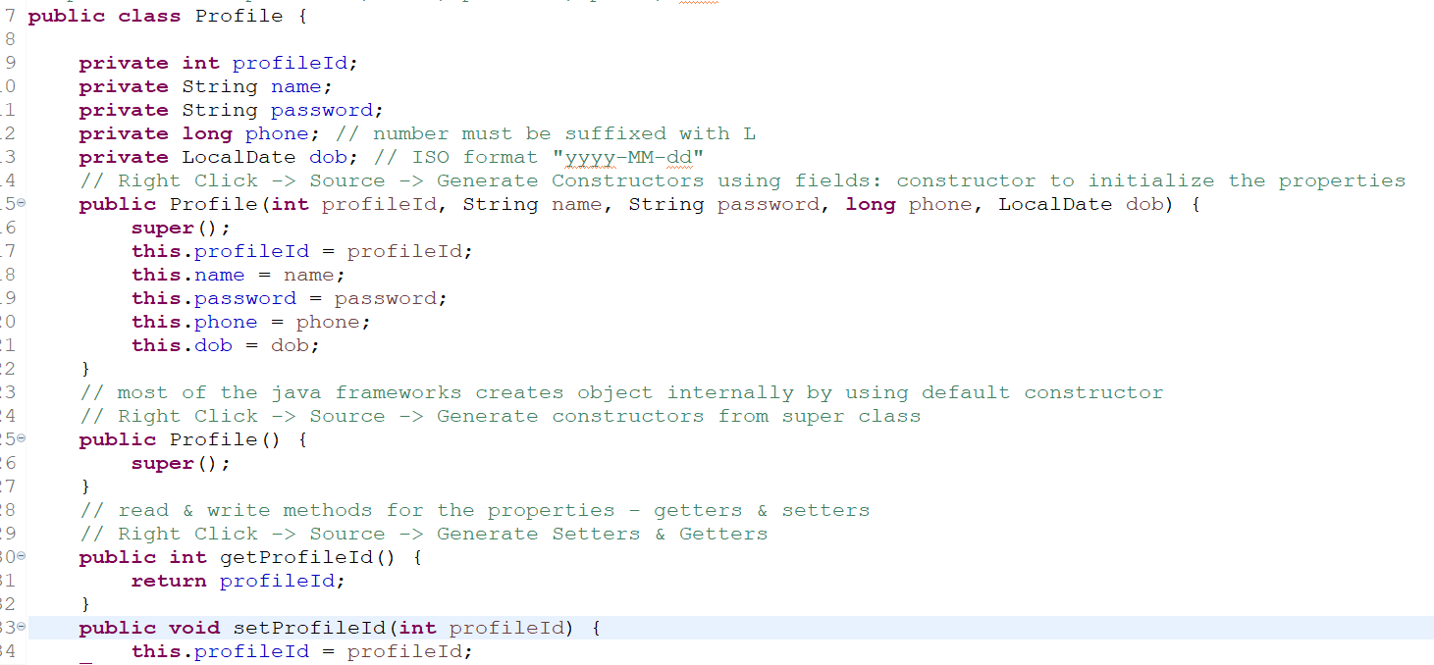

TestProfile.java

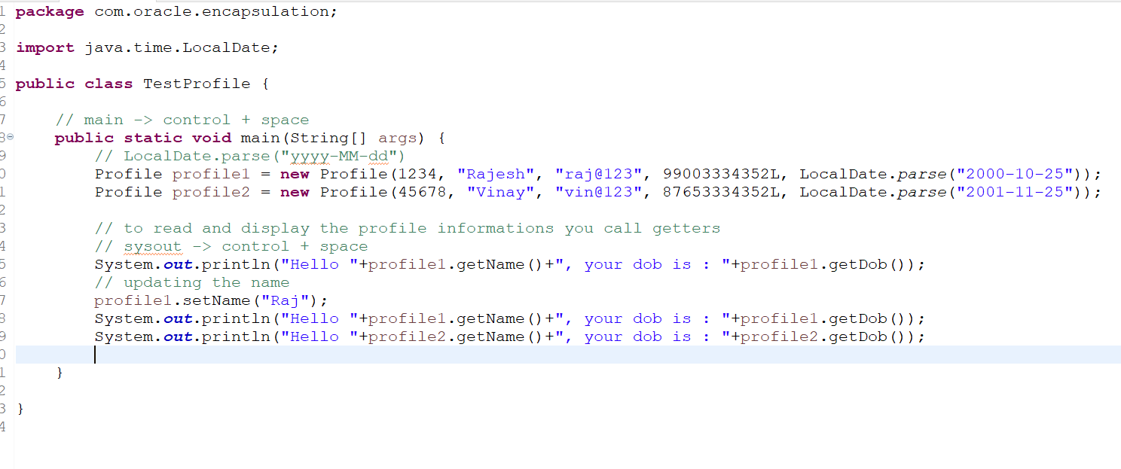

Download Tomcat 10 zip & unzip the file

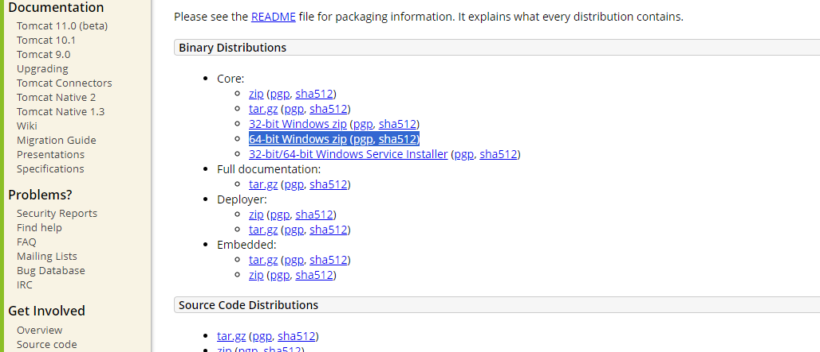

Webservice

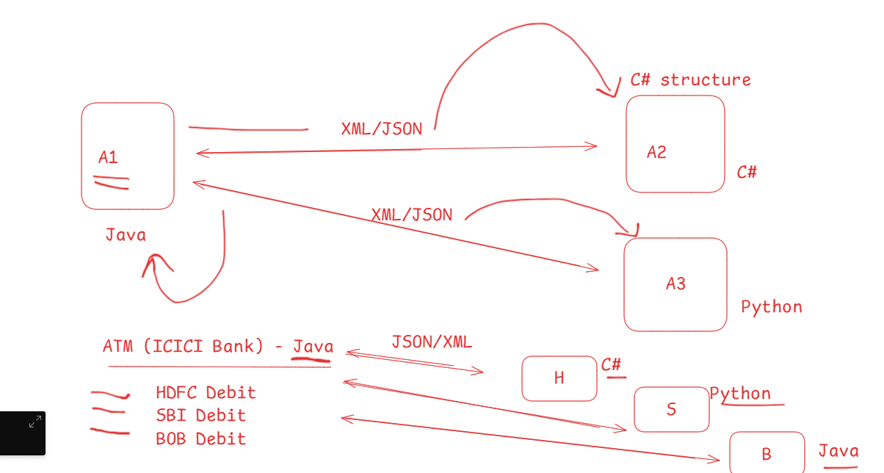

Webservice makes applications written in different technologies to exchange the data in a common format like XML/JSON, these common formats are converted to the respective structure the application is written in

Ex:

Zomato (A) -> Phone Pay(B) ->   
 -> Google Pay (C)  
 -> Simpl (D)

Webservice can use different datastructure also for communication, however JSON/XML more preferred, in that 99% of the time JSON is preferred because its light weight.

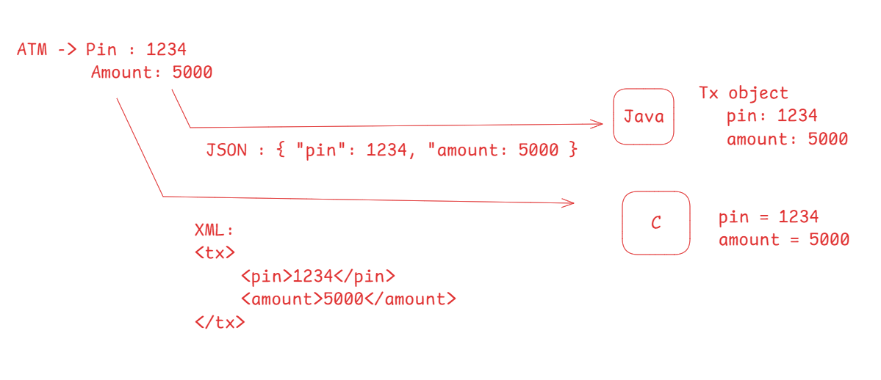

Types of Webservices

1. SOAP Webservice (Simple Object Access Protocol): It is XML based & it is a old webservice before RESTful this was the webservice used
2. RESTful Webservices (Representational State Transfer): It can share the data in various formats like XML, JSON, CSV, Text, HTML and so on

Java has provided specifications for both SOAP & REST

1. JAX-WS: Soap webservice
2. JAX-RS: Rest webservice

Important rules to consider while designing APIs with REST architecture

1. Locate the Web Services using URL
2. Use HTTP methods to access and define the service
   1. HTTP GET: It must be used for reading/fetching the data
   2. HTTP POST: It must be used for creating the new resource
   3. HTTP PUT: It must be used for updating the existing resource
   4. HTTP DELETE: It must be used to delete the resource

JAX-RS has various implementations like

* Jersey
* Rest Easy
* Apache CFX

JAX-RS has provided various annotations to develop the webservices which can be used with any implementations like Jersey, Rest Easy, Apache CFX

@Path, @GET, @POST, @PUT, @DELETE, @Produces, @Consumes, @PathParam, @QueryParam, @Context

Create dynamic web project

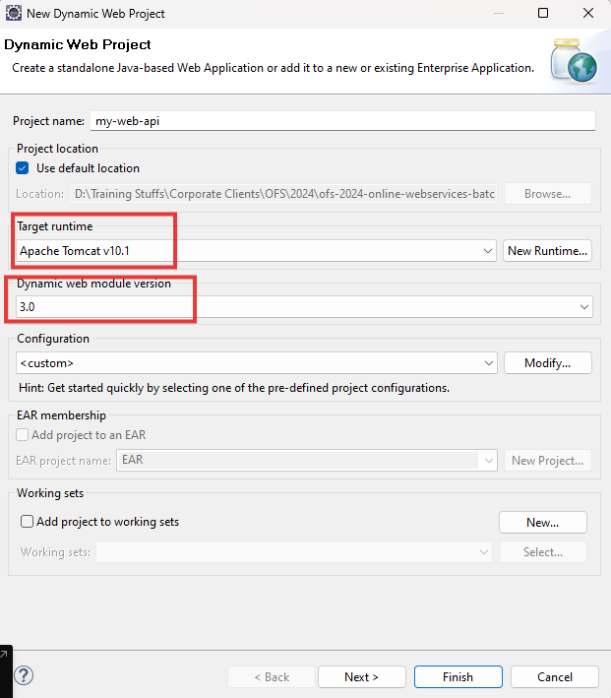

Generate deployment descriptor

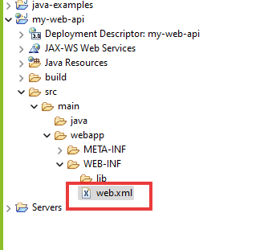

Maven Project: It helps you to add java libraries and their dependencies with the help of XML file, which is a pom.xml file

<dependencies>  
 < dependency >…</dependency>  
 <dependency>..</dependency>  
</dependencies>

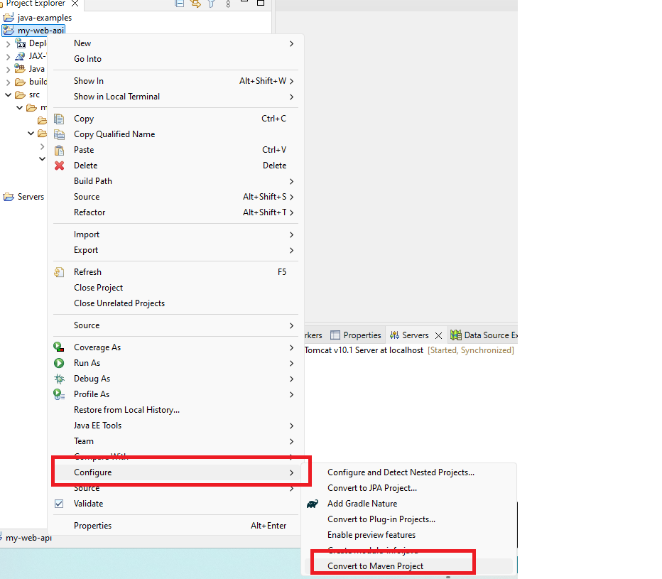

Dependencies for Jersey Implementations

1. Jersey Server
2. Jersey container servlet core
3. Jersey HK2
4. Jersey Media JSON Binding

pom.xml

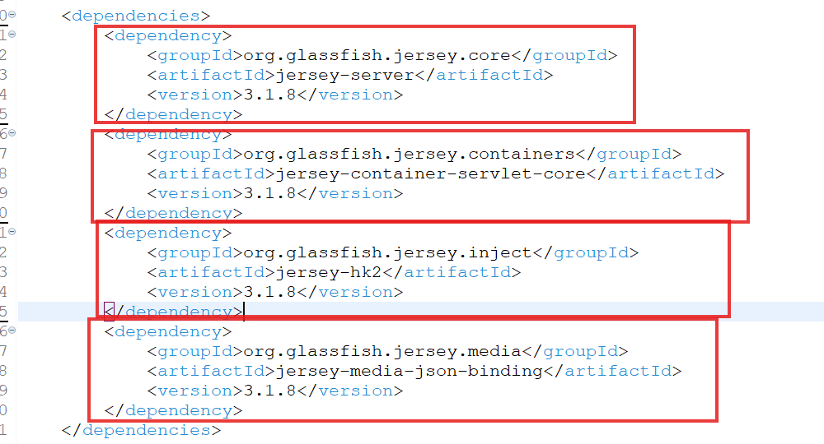

Project Structure

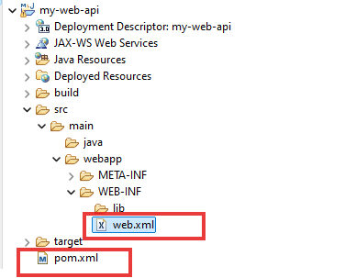

There are 2 xml files

1. pom.xml: This is a maven configuration file, where you will add project dependencies
2. web.xml: This is a project configuration file, where server looks for request mapping

Initial Setup

1. Front Controller configuration - web.xml
2. Creating Controllers: This can handle the requests

Note: Webservice code will be written in the controller

web.xml

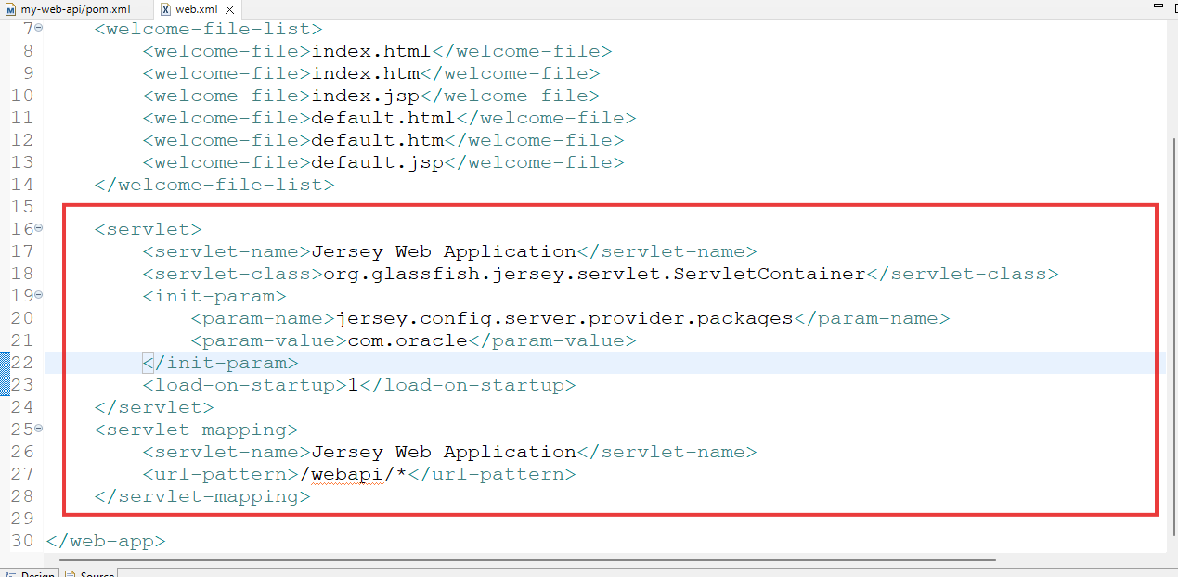

Front Controller takes incoming requests that has /webapi/\* means any sub-path after /webapi/, we must have RESTwebservices configured with a URL, front-controller takes the request & routes to the webservice

Note: You must create your webservice inside the com.oracle package, because <param-value> says the package name is com.oracle

Note: Webservices code are written in the controller layer

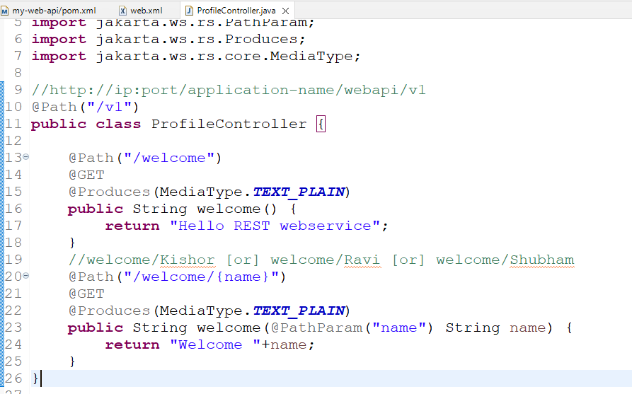

Output:

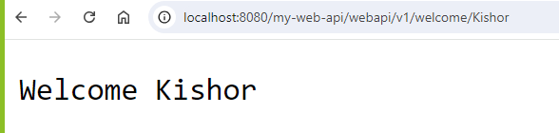

@Path: It is to configure the URL for the resource

@Produces: It is used to produce the data to the clients

@Get: It is used to map the resource with HTTP GET

Tools to test webservice

We cannot test all the HTTP methods using browser, hence we must use some testing tools for webservice like Postman, VS Code Thunder client.

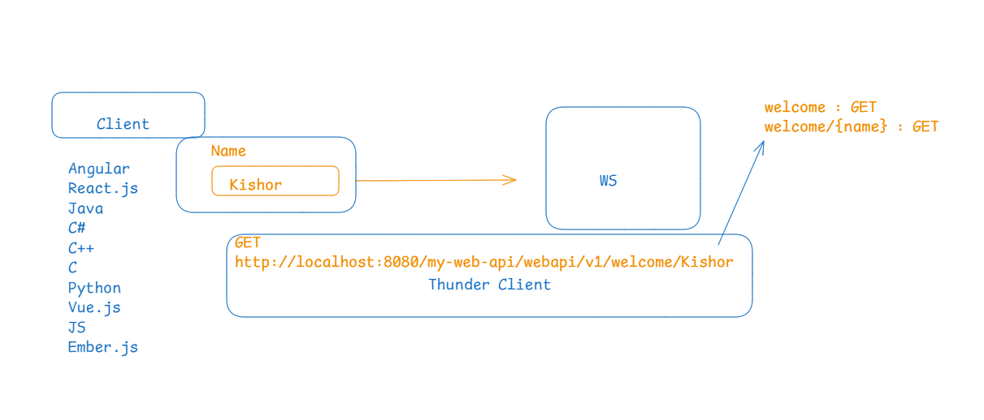

Activity:

Try to create few more methods that gives welcome <<yourname>> in text format with other HTTP methods like post, put & delete, use the same url for all the methods

ex: /welcome/{name}